**Unit:** Sign In Page Functionality

**Source Files:** signin_page.py

**Date:** 11/02/2023

**Engineers:** Anupriya Palanisamy, Likita Pratap

**Automated Test Code:**

import unittest

from sign_in_page import SignInPage

import io

import sys

class TestSignInPage(unittest.TestCase):

    def setUp(self):

        self.sign_in_page = SignInPage()

    def test_sign_in_with_valid_credentials(self):

        result = self.sign_in_page.signIn("user@example.com", "password123")

        if result:

            print("Sign in successful with valid credentials.")

        else:

            print("Sign in failed with valid credentials.")

    def test_sign_in_with_invalid_credentials(self):

        result = self.sign_in_page.signIn("invalid@example.com", "wrongpassword")

        if not result:

            print("Sign in failed with invalid credentials.")

        else:

            print("Sign in successful with invalid credentials.")

    def test_sign_in_with_empty_fields(self):

        result = self.sign_in_page.signIn("", "")

        if not result:

            print("Sign in failed with empty fields.")

        else:

            print("Sign in successful with empty fields.")

if __name__ == "__main__":

   unittest.main()

**Expected Output:**

Sign in successful with valid credentials.

Sign in failed with invalid credentials.

Sign in failed with empty fields.

**Actual Outputs:**

**Test Methodology:**

The testing methodology used here is unit testing, where individual components of the software are tested in isolation. For the sign-in page, we are testing the sign in method to ensure it works as expected for different scenarios (valid credentials, invalid credentials, and empty fields).

* **Test Cases:**
  1. **test_signin_with_valid_credentials:** This test case checks if the sign-in method returns **True** when valid credentials are provided.
  2. **test_signin_with_invalid_credentials:** This test case checks if the sign-in method returns **False** when invalid credentials are provided.
  3. **test_signin_with_empty_fields:** This test case checks if the sign-in method returns **False** when empty fields are provided.

**Unit:** Login Functionality

**Source Files:** login.py

**Date:** 11/02/2023

**Engineers:** Anupriya Palanisamy, Likita Pratap

**Automated Test Code:**

import unittest

from login_page import LoginPage

class TestLoginPage(unittest.TestCase):

    def setUp(self):

        self.login_page = LoginPage()

    def test_login_with_valid_credentials(self):

        result = self.login_page.login("John@gmail.com", "42658")

        if result:

            print("Login successful with valid credentials.")

        else:

            print("Login failed with valid credentials.")

    def test_login_with_invalid_credentials(self):

        result = self.login_page.login("#jo.com ", "852ab ")

        if not result:

            print("Login failed with invalid credentials.")

        else:

            print("Login successful with invalid credentials.")

    def test_login_with_empty_fields(self):

        result = self.login_page.login("", "")

        if not result:

            print("Login failed with empty fields.")

        else:

            print("Login successful with empty fields.")

if __name__ == "__main__":

    unittest.main()

**Expected Output:**

Login successful with valid credentials.

Login failed with invalid credentials.

Login failed with empty fields.

**Actual Outputs:**

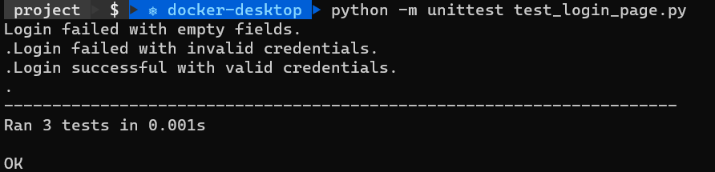

**Test Methodology:**

* **Testing Methodology**: The testing methodology used here is unit testing, where individual components of the software are tested in isolation. For the login page, we are testing the login method to ensure it works as expected for different scenarios (valid credentials, invalid credentials, and empty fields).
* **Test Cases:**
  1. **test_login_with_valid_credentials:** This test case checks if the login method returns **True** when valid credentials are provided.
  2. **test_login_with_invalid_credentials:** This test case checks if the login method returns **False** when invalid credentials are provided.
  3. **test_login_with_empty_fields:** This test case checks if the login method returns **False** when empty fields are provided.